**MECHANICAL LABYRINTH ESCAPE**

**GAME DESIGN DOCUMENT**

**Index**

GAME OVERVIEW 3

ART 4

**DESIGN** 5

**PROGRAMMING** 6-7

**MANAGEMENT** 6-7

**REFERENCES** 7**-**8

**Game Overview**

**What is the Game About?**

**The game is a 2D Platformer where you collect objects and dodging enemies & obstacles while making your way to the exit.**

**Game Theme**

**Sci-Fi & Fantasy**

**Game Genre**

**Platformer**

**Game Platform**

**PC**

**Game Story**

**The Player Character finds himself in another world and the way to get back is in a castle infested with hostile enemies and deadly traps. He needs to collect all the necessary gems before moving on to the gate that would lead him home.**

**Target Audience**

**Everyone**

**ART**

**Characters**

**Hero Characters**

**Enemy Characters**

|  |  |  |  |  |
| --- | --- | --- | --- | --- |
| **N.O** | **Name of Character** | **Type** | **About the Character** | **Abilities** |
| **1** | Hero | Hero | The Player Character. He wakes up and realises he is in another world. With the labyrinth in front of him, he has no choice but to enter and find a way home there. | The Character can Run and Jump over Obstacles and Enemies.  He is endurable enough to survive multiple hits before dying. |

|  |  |  |  |  |
| --- | --- | --- | --- | --- |
| **N.O** | **Name of Character** | **Type** | **About the Character** | **Abilities** |
| **1** | Slime | Villain | It is a standard minion, tasked with patrolling the vicinity and attack any intruders who come by. | The slimes patrol certain areas back and forth. Coming to contact with this enemy will make the player lose 1 life. |

**DESIGN**

**LEVEL DESIGN**

|  |  |  |  |  |
| --- | --- | --- | --- | --- |
| **N.O** | **Region** | **About the Level** | **Objectives of the Level** | **Challenges of the Level** |
| **1** | N/A | The Player must get home but he must get the necessary items to unlock the goal while heading through the castle. | 1. Collect all Items 2. End Goal | 1. Enemy & Traps |

**SOUND DESIGN**

**Background Sound**

BG Sound 1: To be played throughout the whole game.

**Sound Effects**

Sound FX 1: Collectible Get Sound

Sound FX 2: Jumping Sound

Sound FX 3: Hurt

Sound FX 4: Win

Sound FX 5: Lose

**PROGRAMMING**

**GAME SYSTEMS**

**The player can move left and right by pressing the A & D keys as well as Jump with W. However, there is no means of attack, and the player will have to rely on dodging danger.**

**There is a Life system where the player has 3 lives to boot while going through the whole game. Colliding with hazards & enemies will make the player lose a life. Game is over if all lives are lost.**

**For the player to win the game, the player must collect items to make the goal appear at the end of the level. Once the conditions are met, the player can touch the goal to win.**

**When paused, the player can adjust the screen resize to adjust the game window with the mouse.**

**GAME MECHANICS**

There are triggers to pick up the collectibles and touch the enemies as well as a ground checker before and after a jump.

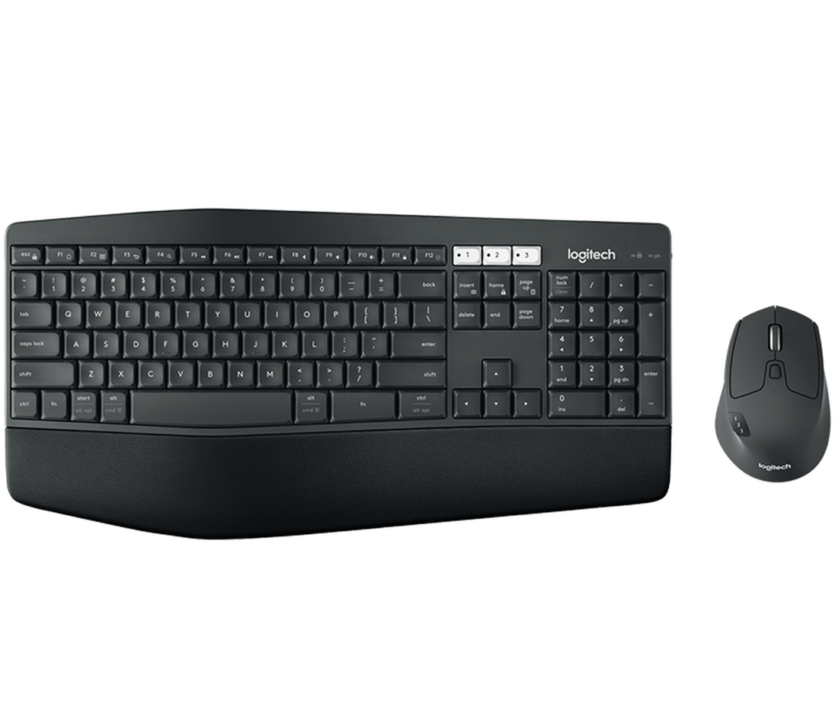

Mouse 1: To interact with the buttons. (On Pause)

ESC Key: Pause/Restart (on GameOver)

W Key: Jump

D Key: Move Right

A Key: Move Left

**MANAGEMENT**

**SCHEDULE OF GAME PRODUCTION (1 Week)**

|  |  |  |
| --- | --- | --- |
| Day | Things to be Start On | Things to be Completed |
| Day 1 | 2D Sprites of Characters, Plan Development | NA |
| Day 2 | Do up Player Character, Plan Development | 2D Sprites of Character, Plan Development |
| Day 3 | Continuing of Developing Player Character, Finishing Up Enemy & Collider | Do up Player, Finishing Up Enemy & Collider |
| Day 4 | Level Development | Level Development |
| Day 5 | Unity Profiler, Test Cases | Level Development, Unity Profiler, Test Cases |
| Day 6 | UAT Testing | UAT Testing |
| Day 7 | Submission of Project | Submission of Project |

**REFRENCES**

Add the references (with accompanying images and website link) of the game assets used for your game.

**SPRITES**

**Player Sprite Link:**

<https://free-game-assets.itch.io/free-3-cyberpunk-sprites-pixel-art>

**Enemy Link:**

<https://opengameart.org/content/platformer-art-complete-pack-often-updated>

**Background Link:**

<https://opengameart.org/content/sci-fi-platformer-tiles-32x32>

**SOUNDS & BGM**

**Jump Sound:**

<https://freesound.org/people/jalastram/sounds/386628/>

**Hit Sound:**

<https://freesound.org/people/MATRIXXX_/sounds/523769/>

**Win Sound:**

<https://freesound.org/people/deleted_user_13668154/sounds/616485/>

**Lose Sound:**

<https://freesound.org/people/colorsCrimsonTears/sounds/609025/>

**Coin Sound:**

<https://freesound.org/people/LittleRobotSoundFactory/sounds/270303/>

**BGM:**

<https://freesound.org/people/joshuaempyre/sounds/251461/>